# 

Youth Expert Angler Citation Award Application

**Please complete all sections of this form. Submit by December 31. One form per angler. *Fish must be caught and released in accordance with Tournament rules.***

Catch Information

(Minimum citation sizes must be met):

|  |  |  |  |  |  |
| --- | --- | --- | --- | --- | --- |
| Species: | Date Caught: | Length: (inches) | Where Caught: | Bait or Lure Used: | How Caught: |
| Choose an item. | Click or tap to enter a date. | Click or tap here to enter text. | Click or tap here to enter text. | Click or tap here to enter text. | Choose an item. |

Angler Certification

Full Name: Click or tap here to enter text. Date of Birth: Click or tap to enter a date.

Street Address (No P.O. Boxes): Click or tap here to enter text. City: Click or tap here to enter text.

State: Click or tap here to enter text.Zip: Click or tap here to enter text.

Telephone Number:Click or tap here to enter text.

Signature of Angler:



I attest the information on this entry form is correct, that I caught this fish on rod and reel without assistance, and the catch was made in compliance with all Tournament rules. I agree to the application of all Tournament rules to this catch and agree to be bound by these rules.

Witness Certification

Witness Name (Printed): Click or tap here to enter text.

Telephone Number: Click or tap here to enter text.

Boat Name (if applicable): Click or tap here to enter text.

Captain Name (if applicable): Click or tap here to enter text.

Fishing Trip Type (circle one): Choose an item.

Witness Signature:



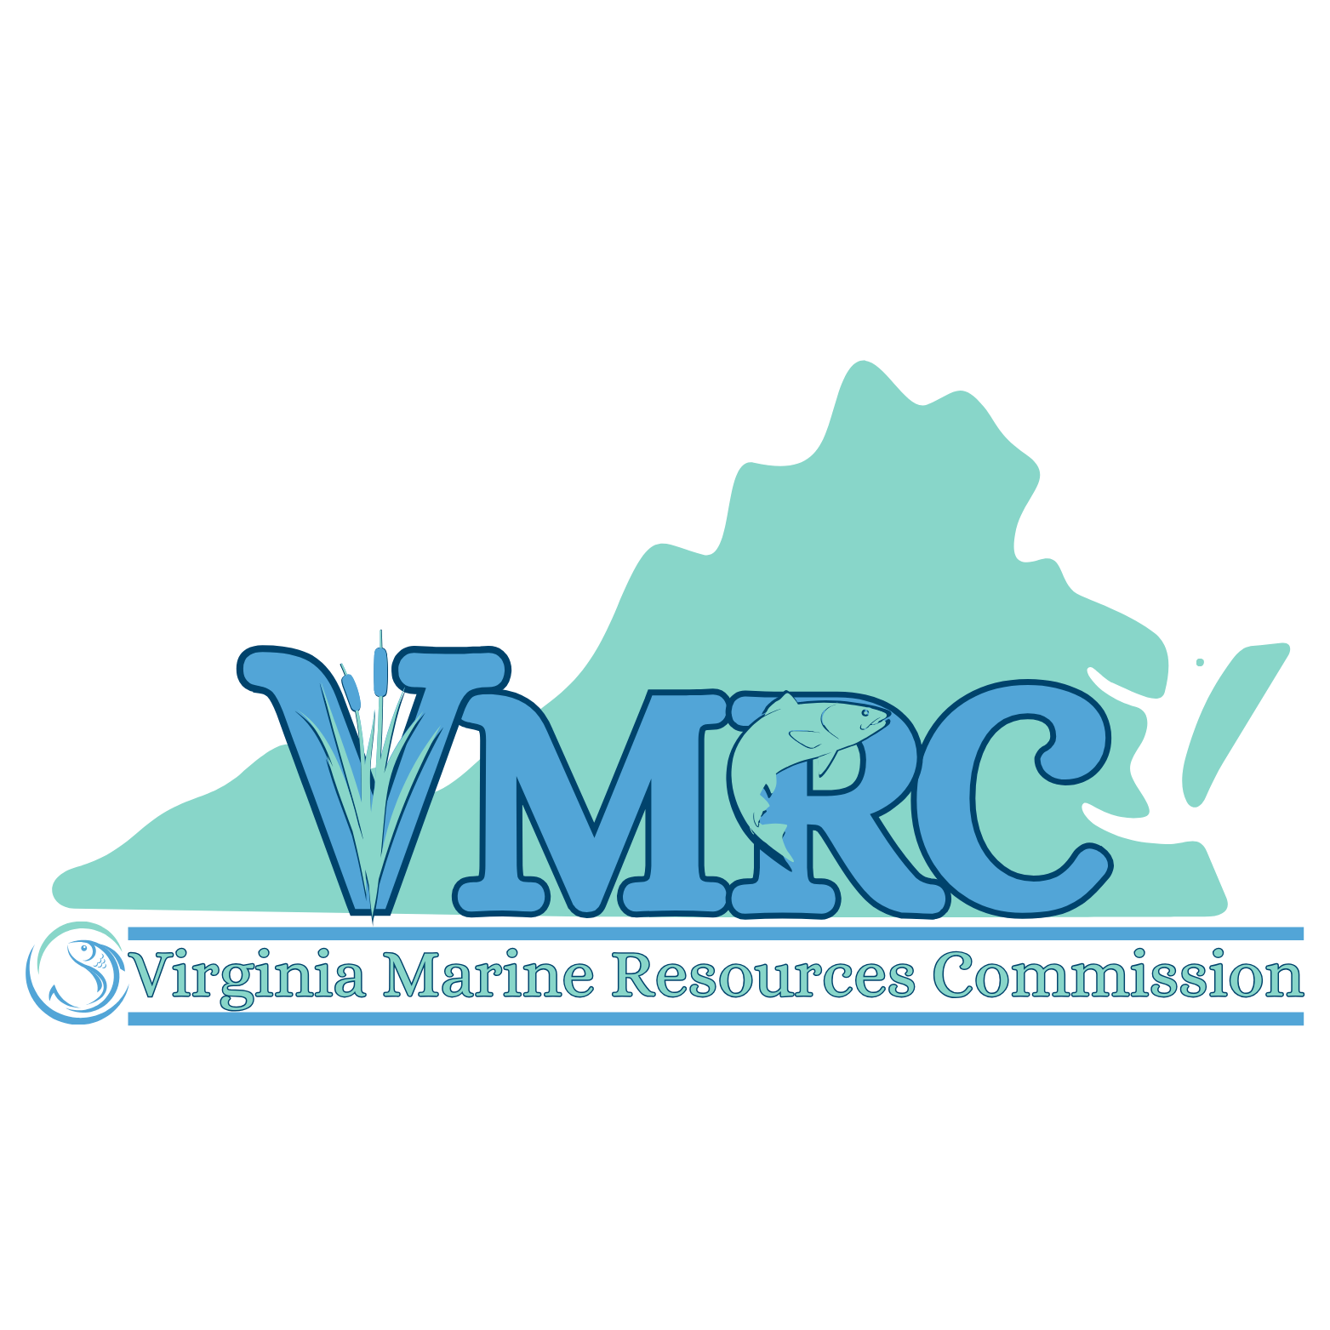I certify that I witnessed the catch of this fish, the catch and release was made in compliance with Tournament rules (including proper measuring of released fish), and the information on this entry form is correct.

Submission Instructions

Submit your completed form by December 31.

Email To: Matt.hargis@mrc.virginia.gov

Or Mail To:  
Virginia Saltwater Fishing Tournament  
Building 96, 380 Fenwick Road  
Ft. Monroe, VA 23651